### Purpose of the application

The purpose of this project was to create an innovative game which utilized the sensors on an Apple Watch to control player motion on the screen of a paired iPhone or other iOS device. In order to do this an iOS app running on an Apple iPhone, iPad or iPod Touch and a WatchOS app running on a paired Apple Watch was needed. After much research and consideration, we came to this idea as we wanted both a challenge and to create something that had previously not been done before.

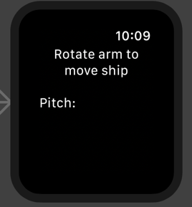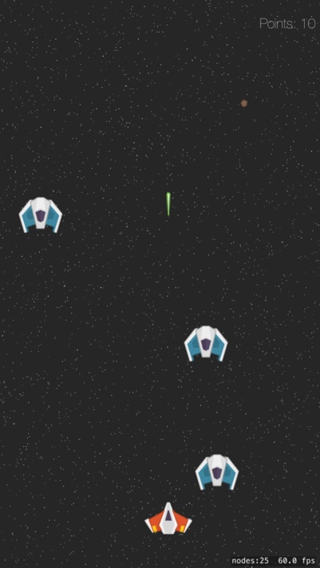Our chosen project was going to be a challenge for a couple of reasons. One we had not previously done any native development on either iPhone or Apple Watch, and on top of this the language we would be writing in was going to be Swift, which we did not have any experience in. The second reason that this would be difficult is that during our initial research there were many aspects to creating this kind of application that were either unclear if they were possible or there was a very limited amount of information that we could draw from online.

### Gestures identified as appropriate for this application - (35%)

consider how gestures can be incorporated into the application, providing a justification for the ones that you pick. This is an important research element for the project and needs to explain how the gestures fit into the solution you are creating.

### Hardware used in creating the application

You are not limited to the hardware listed above. If you have your own hardware, or hardware simulator that you wish to use, then feel free. The purpose of each piece of hardware should be given with a comparison to other options available.

### Architecture for the solution

The full architecture for the solution, including the class diagrams, any data models, communications and distributed elements that you are creating. The architecture must make sense when the gestures and the hardware are combined. Justification is necessary in the documentation for this. You need to include a list of relevant libraries that you used in the project.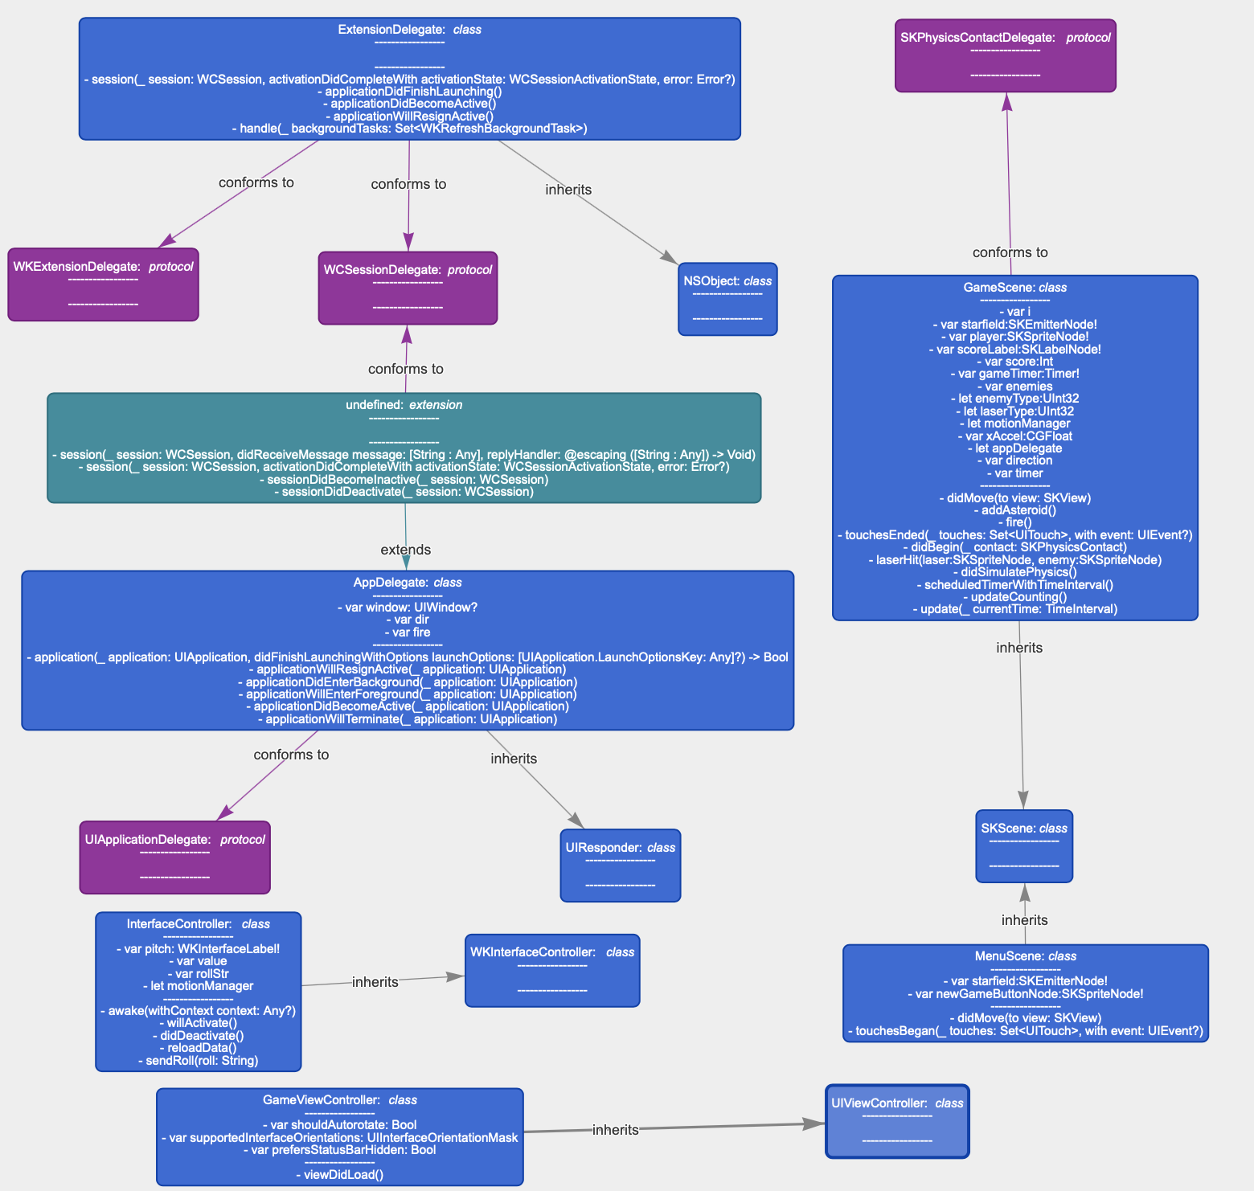

### Conclusions & Recommendations

Conclusions are what you have learned from this project and the associated research. Recommendations are what you would do differently if you were to undertake the project again. The Reflective Piece – what I learned and “enjoyed”! This gives scope for a critical evaluation of the project and the objective that you tried to achieve.